Electronics Workshop Report - 4

*Sricharan Vinoth Kumar (2024112022) & Saikiran. S (2024112007)*

*Table: 23*

* Objective:

To assemble a voltage regulator circuit using (i) a Zener diode, (ii) a LM317 IC, (iii) a 7805 IC.

* Equipment Used:
  + Breadboard
  + Zener Diode
  + LM317 IC
  + 7805 IC
  + Resistors
  + Wires
  + DC Power Supply
  + Multimeter
* Circuit Diagram(s):
  + Voltage Regulator Using Zener



* + Voltage Regulator Using LM317

* + Voltage Regulator Using 7805

* Procedure:
  + Zener Diode:-
    1. Identify the components required for the circuit and assemble the circuit as per the given circuit diagram.
    2. Set the input voltage as 15 volts.
    3. Determine the breakdown voltage of the Zener Diode by checking its datasheet.
    4. Measure the voltage across the load resistance and the current drawn by the circuit. (Which is the same as the current flowing through the series resistance)
    5. Increase the load resistance and repeat Step 3. Tabulate the observed voltage drops and the current drawn.
    6. Identify the load resistance from which the measured voltage stabilizes to nearly a fixed voltage drop, which should be very similar to the rated breakdown voltage of the Zener Diode.
  + LM317 IC:-
    1. Identify the components required and assemble the circuit as per the given circuit diagram.
    2. Set the input voltage as 15 V.
    3. Move the wiper of the potentiometer to create a voltage drop of 10 V across the load resistance.
    4. Measure the values of the resistances of the potentiometer after the required adjustments. Also measure the current drawn by the circuit and the voltage across the Vout and Adjust pins of the IC. (Should be ≈ 1.25 V)
    5. Increase the load resistance and repeat steps 3 and 4. Also observe the current drawn when there is no load, (open circuit). Tabulate the observed values.
  + 7805 IC:-
    1. Identify the components required and assemble the circuit as per the given circuit diagram.
    2. Set the input voltage as 15 V.
    3. Measure the voltage across the load resistance and the current drawn by the circuit. (Which is the same as the current flowing through the series resistance)
    4. Increase the load resistance and repeat Step 3. Tabulate the observed voltage drops and the current drawn.
    5. Identify the load resistance from which the measured voltage stabilizes to nearly a fixed voltage drop (Should be ≈ 5 V) .
* Observation:-
  + Assembled Circuits,

Zener Diode:

The Vin wire and the resistor have been left open to facilitate the measuring of the current drawn

LM317:

7805:

* + Observed Values,

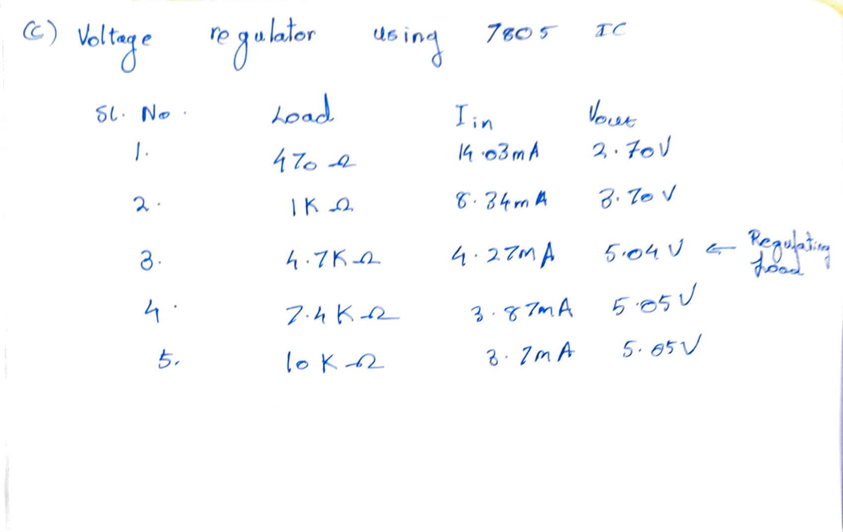

* Result:
  + For the Zener Diode regulating circuit, the minimum regulating load resistance was found to be roughly 4.6 kilohms.
  + For the LM317 IC regulating circuit, the resistances of the potentiometer R1 and R2 are approximately, (most frequent values of R1 and R2)
    - R1 = 0.67 kilohms
    - R2 = 4.58 kilohms

Also the current drawn during no load case (Infinite Resistance/ Open Circuit) was found to be 1.92 mA. This is the current used in the operation of the IC. (i.e, quiescent current)

* + For the 7805 IC regulating circuit, the minimum regulating load resistance was found to be roughly 4.7 kilohms.
* Conclusion:

Voltage regulation circuits using a Zener diode, a LM317 IC and a 7805 IC have been assembled and analysed successfully.

* Sources of Error:
  + Tolerance of Resistor : The actual resistance of the resistor may vary from the rated resistance, causing some inaccuracies between the observed and the expected values.
  + Non-Ideal Behaviour of Zener or ICs : The Zener or ICs may have some additional internal resistances, which can create some error, or their actual regulated voltage output may be different than the rated or expected output voltage.